CS 255 System Design Document
Project Two
Daniel Quintana

UML Diagrams

UML Use Case Diagram

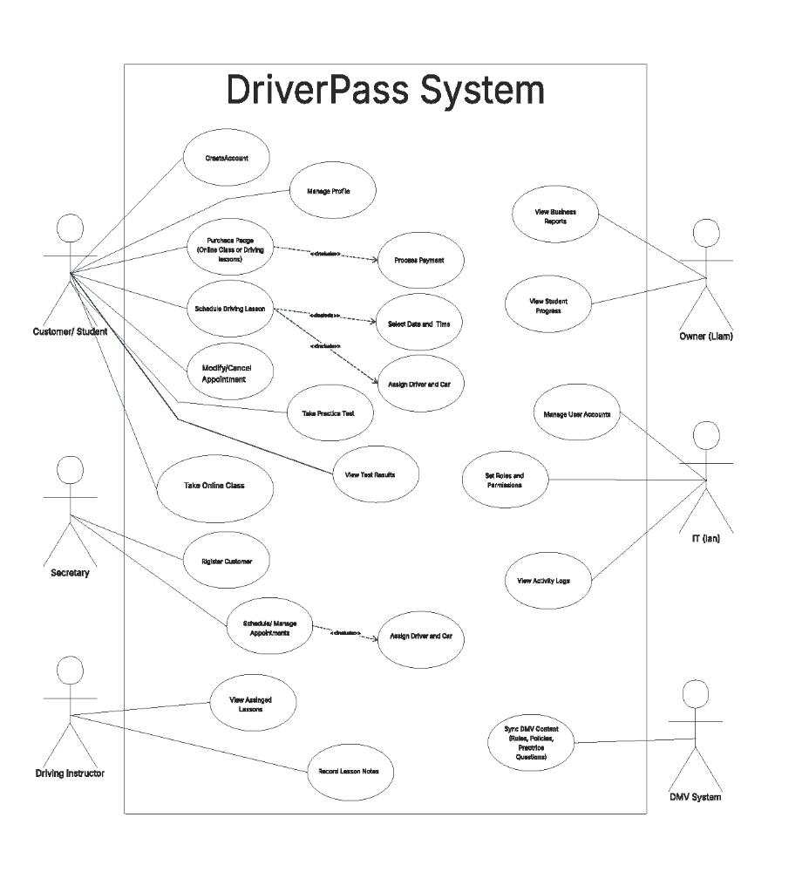

UML Activity Diagrams

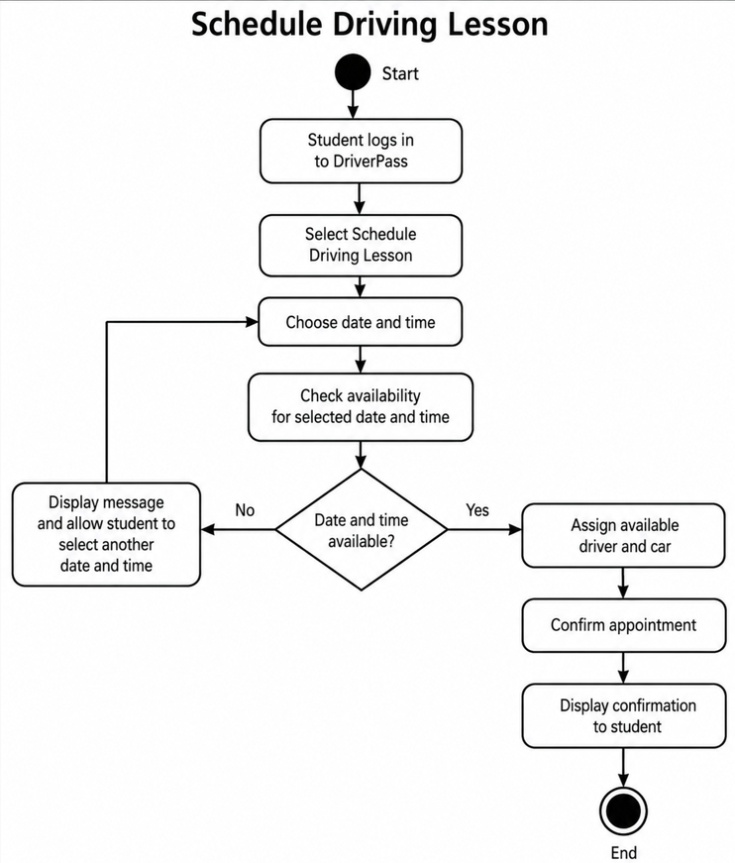
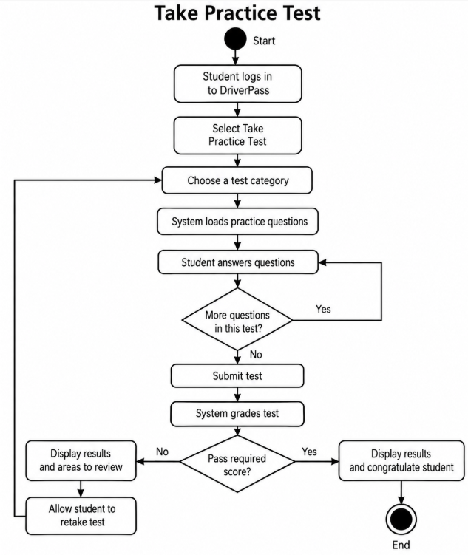

UML Sequence Diagram

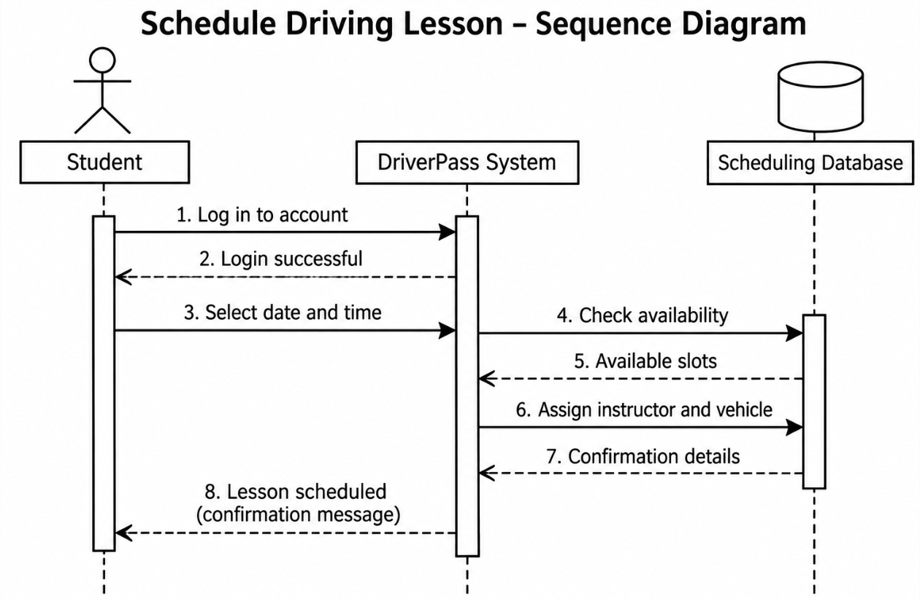

UML Class Diagram

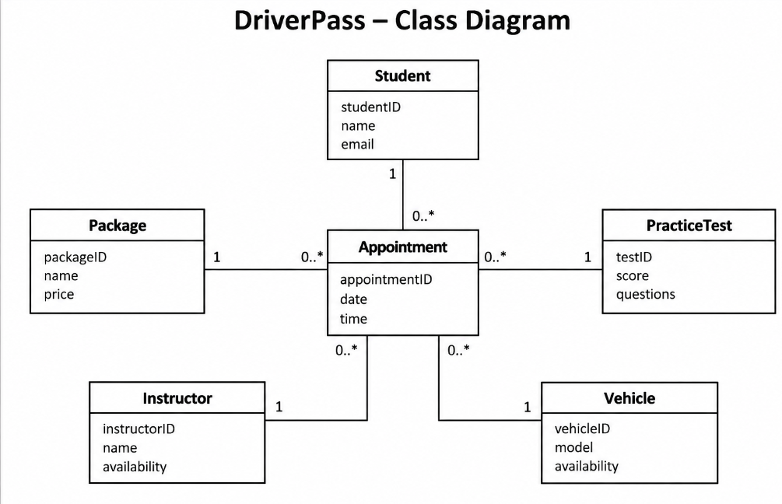

Technical Requirements

The DriverPass system will be web-based so students and employees can access it from a computer, tablet, or smartphone. Users will need an internet connection and a web browser such as Chrome, Edge, or Safari. Employees will need computers to manage appointments, student information, and daily operations. The system will also need a database to keep track of student accounts, appointments, instructors, vehicles, purchased packages, and test results. Students should be able to schedule driving lessons, make payments, take online classes, and complete practice tests. Employees will need access to manage schedules, assign instructors and vehicles, and check student progress.
DriverPass will use cloud-based services so multiple people can use the system at the same time without having to be at the same location. The system will need automatic backup in case something goes wrong, and information needs to be recovered. Security will also be important since the system will be storing personal information. Students should only have access to their own accounts, while employees will have different levels of access depending on their jobs. The system will also need a way to update DMV rules, policies, and practice questions when changes are made. Overall, the goal is to have a system that is easy for students to use and helps employees manage their work without making things more complicated than they need to be.

